Configuration Management Plan for Coke

Revision History

Anytime the document changes, be sure that an entry is added to this table for that revision level.
Document Changes
Date | Rev | Author/Modifier | Description of Changes
2016-04-26 | A | Saravanan Rajamani | Initial version
2016-05-26 | B | Lokesh

Contents
Revision History 2
1. Introduction 4
1.1 Purpose 4
1.2 Scope 4
1.3 Definitions, Abbreviation & Acronyms 4
2. SCM Management 5
2.1 SCM Workflow 5
2.2 SCM responsibilities 6
3. Software Configuration Management 7
3.1 Configuration Identification 7
3.2 Specification of Identification 7
3.3 Central Repository 8
3.4 CM Tools 8
3.5 Project Specific Directory Structure 8
3.6 SVN Work Flow: 9
3.7 SVN Folder/Directory Structure 10
3.8 Source code development should be under trunk 11
3.9 Continuous Integration 11
3.10 Naming Convention for Configuration Items 11
3.11 Release types and naming conventions 12
3.12 Build types 12
3.13 Baseline types and Naming Conventions 12
3.14 Software Configuration Tools identification 13
3.15 Acquiring Configuration Items 13
3.16 Change Control 13
3.17 Change Management Process 14
3.18 Release Planning 16
3.19 Release Verification Stage Activities 16
3.20 Promotion Model 17
3.21 Release Streams 17
3.22 Deployment Process 17
4. SCM Resources 18
5. CM Milestones 18
6. Backup & Recovery 19

- Introduction
[The introduction of the Configuration Management Plan provides an overview of the entire document. It includes the purpose, scope, definitions, acronyms, abbreviations, references, and overview of this Configuration Management Plan.]
  - Purpose
[Specify the purpose of this Configuration Management Plan.]
This document is the Software Configuration Management Plan (SCMP) of the COKE project. The purpose of this document is to define SCM activities, requirements and resources to control the development and maintenance of the Configuration Items (CIs) of the COKE all participants involved in the development.
  - Scope
This SCMP applies to the development and release of all software and related documentation for the COKE project.
The Plan is intended to be applied to each major point release project of the COKE project.

- Specific names of individuals for the SCM resource roles
- Specific dates for schedule items
- Number and purpose Release builds
- Organization and function of development tracks underneath the release project integration track

Definitions, Abbreviation and Acronyms Definitions, Abbreviation and Acronyms Definitions, Abbreviation and Acronyms Definitions, Abbreviation and Acronyms <Give a short description of the scope for the project. Also provide a short description of what is included, and be specific if something is excluded, from the document>
  - Definitions, Abbreviation & Acronyms
Acronym | Description
CI | Configuration item - An aggregation of hardware, software, or both, designated for configuration management and treated as a single entity in the configuration management process.
CM | Configuration Management
PL | Project Lead
SCMP | Software Configuration Management Plan
TL | Test Lead
PM | Project Manager
CP | Client Partner
QF | Quality Function
DAR | Decision Analysis and Resolution
SOW | Statement Of Work
CCB | Configuration Control Board
TBD | To Be Determined
TBW | To Be Written
SAT | System Administration Team
PR | Problem Report - A request for a change submitted to the configuration management tool, documenting a problem identified during system integration and test.
Base Line | A formal, approved document or product serving as a departure point for future releases
CCR | Configuration Change Request - A request for change to a baseline document or system.
<Add more definitions if needed>

SCM Management
  - SCM Workflow
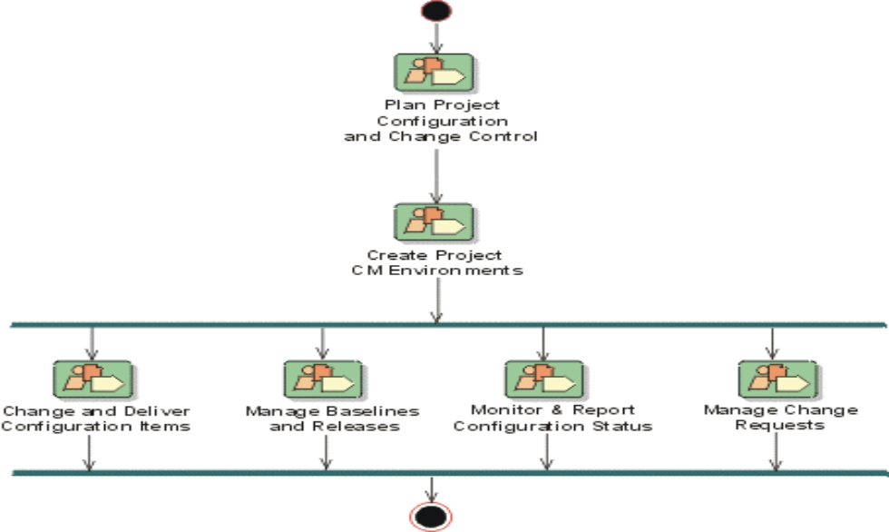

Role | Responsibility
Project Manager | Oversees all project activities, coordinates project schedule sorts out issues and priority. Requests resources from Line managers. Presents status and issues to higher Management.
Tech Lead | Responsible for the functionalities submitted into development track (all components).  Coordinate with different teams to resolve issues from the components.  Coordinates and monitors all activities for which he/she is responsible for  Works with other development leads to resolve design and schedule issues.  Reports status weekly to project manager and test lead.  Supports release integration track merge planning.  Project plan to be verified.
Plan Project Configuration and Change Control | Software Project Manager
Create Project SCM Environments | Environment/Configuration Management
Change and Deliver Configuration Items | Software Engineering Group/Development Team
Manage Baselines and Releases, Conduct Baseline Audits | Software Configuration Manager
Monitor and Report Configuration Status | Software Project Manager  Software Configuration Manager
Manage Change Requests | Project Board  Software Configuration Manager

<Describe the SCM organization
Project manager
CM manager
CM group
CCB group
Audit personnel
etc.
>
  - SCM responsibilities

SCM Activity | Role | Responsibilities
Configuration Identification | Configuration Manager | Identify the Dev Tracks required to meet release project’s needs
Configuration Identification | Configuration Manager | Identify software CIs and how they are to be uniquely named. Identify how the software CIs is to be tracked, stored and retrieved. Setup the development tracks and the release track.
Configuration Identification | Configuration Manager | Identify documentation CIs and how they are to be uniquely named.
Configuration Control | Component Team Lead | Provide support to evaluate change requests.
Configuration Control | Project Manager | Receiver of the Change Request. Approves or rejects change requests once they have been evaluated (impact analysis).
Configuration Control | Developers | New Functional implementation and Implements change requests as development activities
Configuration Control | Configuration Manager | Processes changes on Release Track
Configuration Control | Configuration Manager | Merges changes from Branch Tracks into the Release Track
Configuration Control | Testing/QA Lead | Ensures that changes have been tested appropriately
Configuration Status Accounting | Testing/QA Lead | Provides various reports on the release project development status and testing status
Configuration Audits and Reviews | External QA (BU) | Initiates, conducts and approves formal audits
Configuration Audits and Reviews | Project Manager | Supports formal audits
Configuration Audits and Reviews | Testing/QA Lead | Supports formal audits  Initiates, conducts and approves release integration track merge reviews
Configuration Audits and Reviews | Configuration Manager | Supports release integration track merge reviews
Configuration Audits and Reviews | Configuration Manager | Supports release integration track merge reviews
Interface Control | Component Team Leads | Agree on and document interfaces between software components through the software design process
Release Management and Delivery | Configuration Manager | Creates the release integration track Merge Plan  Provides final release approval along with release documentation
Release Management and Delivery | Configuration Manager | Project version release
Release Management and Delivery | Configuration Manager | Package Deployment

Software Configuration Management
  - Configuration Identification
The software configuration identification activity identifies the configuration items (CIs) to be controlled, establishes naming conventions for the items and their versions, and establishes the tools and techniques to be used in acquiring and managing controlled items.
  - Specification of Identification
Configuration Item | Description
Documentation | Product Documents:  - Release Documentation (RD)  - Test Procedures (TP)  - System Overview (SO)  - Design documentation  - Programmer Reference Manuals (PRM)  - Progress reports  - Configuration Audit & Review Records
Software | In general, each software component CI includes all source code, configuration files, data and data definition files, picture files, testing data and tools, and deliverable software installation packages.
  - Central Repository
Configuration Management Tool(s) used in the project | SVN
Full path of Project Central Repository including server name for documents | Ex: xxxxx
Full path of Project Central Repository including server name for Source Code | Ex: https://63.128.188.19/svn/008061
Who is responsible for maintaining this Central Repository? | xxxxx
  - CM Tools
Source code/Build management tools | Version | Installation path
SVN | xx | xx
Jenkins | xx | xx
Any point studio | xx | xx
Cloudhub | xx | xx
Tibco | Xx | xx
Testing Tools | xx | xx
HPQC | XX | XX
  - Project Specific Directory Structure

Artifacts type | Directory name
Source Code → HRWorkdays | https://63.128.188.19/svn/008061/HRWorkdays/Branch/Source
Source Code → ELM (folder name is changeable)
Source Code → NMS (folder name is changeable) | https://63.128.188.19/svn/008061/icoe/mule/NMS/Branch/Source/Interface_1  https://63.128.188.19/svn/008061/icoe/mule/NMS/Branch/Source/Interface_2 ..  https://63.128.188.19/svn/008061/icoe/mule/NMS/Branch/Source/Interface_n  After Build  https://63.128.188.19/svn/008061/icoe/mule/NMS/Trunk/Source/Interface_1  https://63.128.188.19/svn/008061/icoe/mule/NMS/Trunk/Source/Interface_2 ..  https://63.128.188.19/svn/008061/icoe/mule/NMS/Trunk/Source/Interface_n
Source Code →
Source Code →
Source Code →
Source Code →
Source Code →
Source Code → Others(folder name is changeable)
Build → .xml file/properties (folder name is changeable) | For build
Document → | XXXX
Document → Comprehensive Design(folder name is changeable) | XXXX
Document → Release Note(folder name is changeable) | XXXX
Document → Testing(folder name is changeable) | XXXX
  - SVN Work Flow:
Below is the SVN process we will follow. Code will be checked into the branch folder with each individual component being stored in a separate folder under the corresponding project’s root folder. After the development is complete the build phase will move each component folder into the trunk folder with the same structure. For e.g., let’s take the case of the NMS project and let’s assume that it has 10 interfaces to be built. The code for each of these components will be stored in SVN in the below folder structure.
https://63.128.188.19/svn/008061/NMS/Branch/Source/interface_1

w-r-t→https://63.128.188.19/svn/008061/NMS/Trunk/Source/Phase-I/FreeStyleBottlerIntegration
https://63.128.188.19/svn/008061/NMS/Branch/Source/interface_2
.
.
….
https://63.128.188.19/svn/008061/NMS/Branch/Source/interface_10
After the code development is complete, tested and code been reviewed the build phase will move each corresponding folder to the trunk folder as below.
https://63.128.188.19/svn/008061/NMS/Trunk/Source/interface_1

w-r-t→https://63.128.188.19/svn/008061/NMS/Trunk/Source/Phase- I/FreeStyleBottlerIntegration

https://63.128.188.19/svn/008061/NMS/Trunk/Source/interface_2
.
.
…
https://63.128.188.19/svn/008061/NMS/Trunk/Source/interface_10

All files under branch and trunk folders will have a version number 1.0. Now let’s assume a defect arises in interface_2 and requires a change in a file stored in folder https://63.../Interface_2. In this case this file alone is changed and after the build phase this file alone is moved from Branch to Trunk under the corresponding folder structure. At the end of the build phase this file alone will have the version 1.1 in both Branch and Trunk. Please confirm.
  - SVN Folder/Directory Structure
SVN Folder/Branch type | Directory name
Trunk | To maintain Stable Release
Branch | Continue development activities. Once the code is stable in to SIT then we will merge to Trunk
Tag | Apply Label to identify the release type.
  - Source code development should be under trunk
For each project/module daily check-in check-out should be done under trunk only and daily release should be done through the trunk for any defect fix that is not part of the current release will be done through the branches and check-in should be done in both the trunk and branches. Tag folder will maintain the build versions

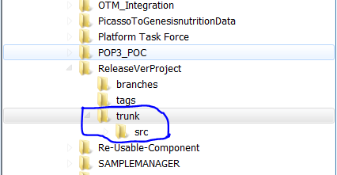
  - Continuous Integration
Daily build and release to the next level should be done through the continuous integration tools like Bamboo, Jenkins and Artifact should be stored in storage server to maintain the all the versions of the artifact properly
  - Naming Convention for Configuration Items
Naming conventions exist for files and directories within each CI and for each CI product kit. The naming conventions are split between documentation, server software and client software categories
Below table lists the CI naming conventions (or references to them) that are being used for the coke project.

Item |  | Naming Convention
Documentation CI
Client Software CIs | Source Files & Directories | Follows standard Microsoft Windows and Visual Studio naming conventions for filename extensions and development directory structure
Client Software CIs | Product /zip/war/jar files - for Production release | <PRODUCT>-<x>.<y>.<z>  i.e. NMS-16.02.1.1.zip  NMS – Product name  16 – year  02 – month  1.1 – version of change
 | Properties files | Project-environment. Properties
  - Release types and naming conventions
Define the types of releases

- Daily Release: This release to check the compilation errors of daily check in
- Major Release: Features substantial functional enhancements to your existing software
- Minor Release: Features significant, but fewer, functional enhancements to your current software
- Maintenance Release: Fixes software discrepancies discovered since the current major, minor, or previous maintenance release was issued, and may include high priority enhancements
- Emergency Release: A release issued in response to a specific problem that has been reported by a customer
  - Build types
- Daily Scheduled build
- On-Demand build
- Production build
  - Baseline types and Naming Conventions
Baselines are used to identify the versions of the CIs at specific times during the software release project life cycle. Different types of baselines exist for documentation and software configuration items

Baseline type | Purpose | Resp. | Baseline Plan
Requirements Baseline | Establish product characteristics to be used throughout the project. | CCB
Project Baseline | Establish the characteristics and environment to be used throughout the entire project.  The primary users are project management. | CCB
Functional Baseline | Establish functional solution to be used for design, implementation, formal tests, and user documentation. Formal tests is used to secure the contents of implementation baseline | CCB
Design Baseline | Establish functional solution to be used for design and implementation of the specified functionality | CCB
Temporary Implementation Baseline | Establish completed implementation of functions to be used for verification when there is remaining implementation for other functions in the same source code. | CCB
Implementation Baseline | Establish completed implementation of functions to be used for verification and validation. | CCB
Release Baseline | Establish contents of released products. | CCB

  - Software Configuration Tools identification
- Subversion: Version Control
- Jenkins: Continuous Integration
- Maven, Groovy: Deployment Scripts
- HPQC: Defects tracking / Requirement Management
- Maven: Build tool
  - Acquiring Configuration Items
The appropriate methods and tools used to acquire projects configuration items is described in below Table

Item | Method of Acquiring CI’s
Documentation CI | - All official Disney project documentation is acquired and managed using the Troom Capgemini web page In general, Troom provides the ability to upload and download documents.  - Project documents are placed in “Shared documents”
Application Development will take place | - All software source files are maintained in the Version Control configuration management tool. Version Control should support cross platform support. Source code modification should happen in the industry standard IDE’s (ex: Eclipse)
Source Files & Directories | - All application software source files are maintained in Version Control tool (ex: SVN, GIT, CVS, Clear Case)
Release *.jar or *.war files | - All available deployment versions for release components are located on the Repository Server.

  - Change Control
Software configuration control is concerned with managing changes during the software life cycle. It covers the process for determining what change requests to make, the authority for approving certain change requests, and support for implementation of those change requests.
Configuration control activities request, evaluate, approve or disapprove, and implement changes to baselined CIs. Changes encompass both error correction and enhancement. The degree of formality necessary for the change process depends on the project baseline affected and on the impact of the change within the configuration structure
For each project software library identified a plan, the Plan shall describe the change controls imposed on the baselined CIs. The Plan shall define the following sequence of specific steps:
a) Identification and documentation of the need for a change;
b) Analysis and evaluation of a change request;
c) Approval or disapproval of a request;
d) Verification, implementation, and release of a change.
The Plan shall identify the records to be used for tracking and documenting this sequence of steps for each change. Any differences in handling changes based on the origin of the request shall be explicitly documented.
  - Change Management Process
Change Proposal
Document Change

Review
Reject

Approve
Implement
Verify

Request for Change
The change request plan shall specify the procedures for requesting a change to a baseline CI and the information to be documented for the request. As a minimum, the information recorded for a proposed change shall contain the following
a) The name(s) and version(s) of the CIs where the problem appears
b) Originator’s name and organization
c) Date of request
d) Indication of urgency
e) The need for the change
f) Description of the requested change
Additional information, such as priority or classification, may be included to clarify the significance of the request and to assist in its analysis and evaluation. Other information, such as change request number, status, and disposition, may be recorded for change tracking

Evaluating Changes
The change request plan shall specify the analysis required to determine the impact of the proposed change and the procedures for reviewing the results of the analysis. Changes should be evaluated according to their effect on the deliverable and their impact on project resources

Approving or Disapproving
The change request plan shall identify each configuration control board (CCB) and its level of authority for approving proposed changes. A CCB may be an individual or a group. Multiple levels of CCBs may be specified, depending upon the degree of system or project complexity and upon the project baseline involved. When multiple CCBs are used, the change request plan shall specify how the proper level is determined for a change request, including any variations during the project life cycle. For any CCB utilized, the change request plan shall indicate its level of authority and its responsibilities

Release Management and Delivery
Start
Build
If successful
Add Certification file
Deployment
Deployment on Stimulator
End
Yes
Yes
No

Build and deployment flow chart for *.ipa and apps
If successful
Start
Build
Artifact Repository
Deployment to TCService instances
End
Yes
No
Build & Deployment flow chart for *zip *.jar and *.war files
  - Release Planning
It is important to note that each development activity is developed in whole on a single development track. There are cases where a particular development activity is consumed by more than one development track, and in fact is required to start and/or complete other development activities on other development tracks. These types of development activities must first be merged into the release integration track when they are completed, and then are available for the other development tracks to upgrade to. Careful merge planning is required to ensure that development activities that are consumed by multiple development tracks are completed early in the release project cycle and on time.
  - Release Verification Stage Activities
After this a Basic Verification Test takes place to ensure that all major functions work. In addition, for a System Release, a complete Pre-AT is performed on all functions, and for a Revision or Correction Release, a selective number of test procedures are executed. Corrections can be done during this stage
The formal Internal Acceptance Testing (AT) will then be performed by the SIT based on the pre-release system
The reported errors are corrected in parallel with the IAT execution. The final corrected system will then be verified by executing a Basic Verification Test and a selective number of detailed test procedures. The selection of these test procedures is determined by the types of problems uncovered during IAT
  - Promotion Model
The diagram below refers to the release model which maps out the project’s various development, Test and Production environments
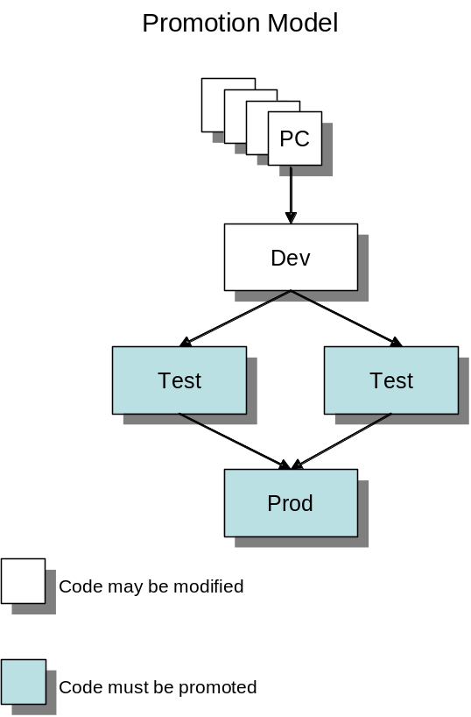
  - Release Streams
The various release streams for each project should be encapsulated in each project’s development plans. This should at the very least include
  - Development
  - Unit Test
  - Integration Test
  - Pre-prod / prod –1
  - Production
Different release streams are supported utilizing the SCM tool-set parallel development facilities
  - Deployment Process
The deployment process for project code promotion is dependent on the model in place for the particular program. The general process is that the deployment phase is under the control of the Release Manager allocated to the project release. Where a Release Manager from the central pool is not available then the project / programs must allocate a resource to perform Release Manager Function, which is to ensure that the release is performed in a controlled fashion and that all tasks required to perform the release are completed successfully. The deployment should be initiated, co-ordinated and ultimately closed by the Release Manager function.
The deployment should be performed on either a manual, semi-automated or fully automated basis, with monitored automation being the recommended option where possible. Whatever method is employed there must exist suitable checkpoints at which the status of the deployment can be monitored and signed-off. The checkpoints are best established on a project basis to enable appropriate controls in place.
The sequence of steps to implement a deployment is controlled by the release note, which must be controlled as a CI. This process must ensure that all code will be promoted / deployed to various test and production environments as the release note and implementation plans.
The Release Manager creates an implementation checklist / plan, which includes tasks, other than the actual promotion of the code, to be completed in the Production environment by the appropriate Coke team and/or the Environment Deployment Team. The promotion checklist lists task to be completed, who is responsible, and when it will be done. The promotion checklist is reviewed prior to the promotion with everyone who has assignments, via regular walkthroughs. The implementation plan is updated with a status as the implementation progresses

- SCM Resources
COKE project release components are executed under the production environments. All personnel resources required to staff the release project are committed to the production release.
It is expected that all resources are trained in the use of the SCM tools to be used prior to being included in the release project. CM training which is specific to the release project will be provided through short training session meeting(s) just after the project work started. The material for the training will be created by the SCM engineers.
SCM tools to use on COKE project releases are as follows:

- Version Control : Subversion (SVN)
- Continuous Integration Tool: Jenkins
- Deployment Scripts : Artifacts Deployment through Maven scripts
- Defects tracking / Requirement Management : HPQC
- Build tool : Maven, Any point design studio
- Document Repository :
- Requirement Management and test cases repository : HP Quality Control

CM Milestones
Identify what the criteria are for reaching each milestone
The CM Plan will be updated when changes to the project such as, resources, direction, or goals, necessitate a revision

Backup & Recovery

